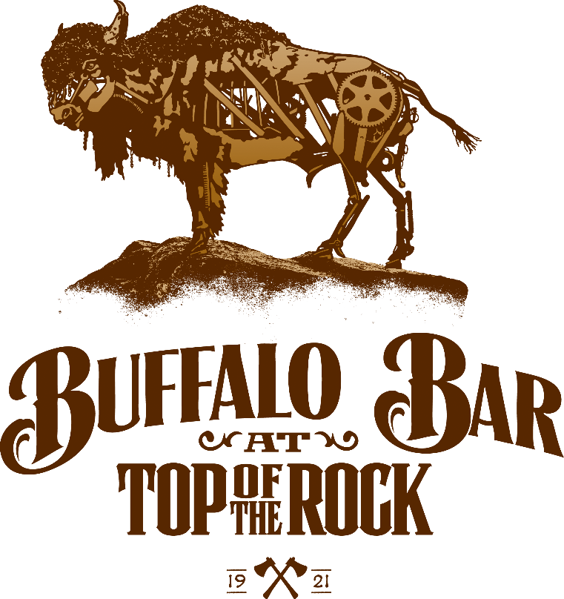

Signature Cocktails
Guava Mezcal $23
Monte Lobos Mezcal, Handcrafted Guava and Cardamom Syrup, Orange Bitters

Harvest Mule $18
Builder’s Gin Barrel Aged, Apple Brandy, Simple Syrup, Ginger Beer, Fresh Lemon Juice

Table Rock Sunset $15
Tito’s Handmade Vodka, Grapefruit Juice, Lemonade, Grenadine

BCL-Old Fashioned $23
Top of the Rock Maker’s Mark Private Select, Simple Syrup,
Blend of Bitters, Luxardo Cherry

Gin Butler $19
Builder’s Gin Barrel Aged, Chambord, Blackberries,
Honey Syrup, Rosemary, Juniper

TOR Tini $19
Grey Goose Pear Vodka, Hennessey VSOP, Molasses,
Lemon Juice, Symple Syrup, Chocolate Bitters

Mandarin New Fashioned $23
Jefferson Rum Cask, Mandarin Orange Syrup, Vanilla Bean,
Bitter Blend, Dehydrated Orange, Luxardo Cherry

Spiced Bison $16
Buffalo Trace, Apple Cider, Cinnamon

Cannonball $15
Bourbon, Amaretto, Pineapple Juice, Prickly Pear Puree
Bottle Beer

Coors Light, Miller Lite, Budweiser - $6.50
Blue Moon, Corona, Stella Artois, Sweet Water Pale Ale,
Modelo Negra, Boulevard Tank $7.50

Draft Beer

Bud Light, Michelob Ultra - $6.50
Rogue Hazelnut, Public House Elusive IPA- $7.50
Table Rock Red, Samuel Adams Octoberfest, Mother’s Mr. Pumpkin - $8.50

WINES BY THE GLASS

White Wines

Cuvee Beatrice Prosecco, Italy NV $12/$46
White Peach, Almond, Orchard Blossoms, Lemon Zest, Spice
Domino Moscato, Manteca California 2018 $9/$34
Sweet and Fruity, Nectarine, Tropical Fruits, Sugary Aromas, Soft Texture
Willamette Valley Vineyards Riesling, Oregon 2018 $10/$38
Pear, Pineapple, Honeysuckle, Notes of Apricot & Tart Apple
Emmolo Sauvignon Blanc, Napa Valley 2019 $12/$46
Melon, White Peach, Acidity, Minerality, Lime Citrus Finish
Four Graces Pinot Gris, Dundee Hills 2019 $12/$46
Lychee Fruit, Mandarin, Grapefruit Zest, Sweet Meyer Lemon, Orange Blossom
Boen Chardonnay, California 2018 $13/$48
Ripe Luscious Fruit, Butter, Baking Spices, Soft Acidity, Lingering Finish

Red Wines

Boen Pinot Noir, Russian River Valley 2018 $14/$54
Raspberry, Boysenberry, Black Fruit Jam, Bright Acidity, Warm Toasted Oak
Belle Glos Balade Pinot Noir, Santa Maria 2016 $18/$72
Blackberry Jam Aromas, Raspberry Tart, Toasted Oak
Trapiche Malbec, Mendoza 2019 $13/$50
Plum, Black Cherry, Hints of Black Pepper, Toasted Oak
Angeline Merlot, Paso Robles 2018 $13/$50
Blackberry, Plum & Hints of Clove
Z. Brown Uncaged Cabernet Sauvignon, North Coast 2018 $14/$54
Black Cherry, Mocha, Sweet Toasted Oak, Smooth Bold Tannins, Milk Chocolate
Daou Cabernet Sauvignon, Paso Robles 2017 $16/$62
Black Cherry, Currant, Plum, Blackberry, Notes of Cranberry & Rhubarb
Bonanza by Caymus, California Lot 2 $17/$64
Currants, Blueberries, Blackberries, Warm Spiced Vanilla, Unsweetened Chocolate

